
Rhondda Ladies Hockey Annual Report 2026
The Club continues to give members opportunities to develop their skills and
enjoy hockey at both junior and senior levels. From May to July 2025, members
were offered our full ‘Summer of Hockey’ programme. Junior sessions and
Back to Hockey continued to run on Monday nights until the end of June
Summer 7s at Sue Noakes and the opportunity to play in the S. Wales Mixed Hockey League. We teamed up with Gwent Hockey Club and entered the Mixed League as Gwendda, playing matches throughout June and July. Our members were delighted to have the opportunity to play one of those matches alongside Wales and GB player, Jacob Draper!
In August 2025, we worked with Sport RCT offering a Junior hockey camp as part of their ‘Summer of Fun’ programme. The take up for this event was so high that we added an extra camp later in the month!

Our newly refurbished changing rooms were opened in January 2026, and we hope the new storage facilities at the school will be available for the start of the 2026 season. Sport RCT helped us with the purchase of two additional Mini Hockey goals and a grant to purchase some much-needed hockey equipment to support the delivery of our Junior and Senior training sessions. Friends of Welsh Hockey helped with the purchase of some new goal keepers kit, which was very much appreciated!

Once again, we entered three teams into the South Wales Women’s League and enjoyed one of our best seasons as a Club. Our 1st Team had a fantastic season, coming top of their League and gaining promotion back up to Prem 2. They won 15 games, drew 1, lost 2 and scored a whopping 63 goals! Our 2nd Team also had a brilliant season, finishing in 4th place in Division 3. They won 8 games, drew 7, lost 4 and scored an amazing 32 goals! We are delighted to report that our 3rd Team also enjoyed one of their best seasons in a number of years. They played 16 matches, won 7, drew 2, lost 7 and scored 24 goals, a wonderful achievement. Huge thanks are extended, on behalf of the Club, to all our Captains and Vice Captains for the work they have done both on and off the pitch throughout the season.
Our Senior membership numbers (Thursday night sessions) stand at 43 and our Junior membership numbers (Monday night sessions) stand at 22. We are also delighted that our Back 2 Hockey sessions continue to prove popular with 11 members enjoying some fun hockey and keeping fit!

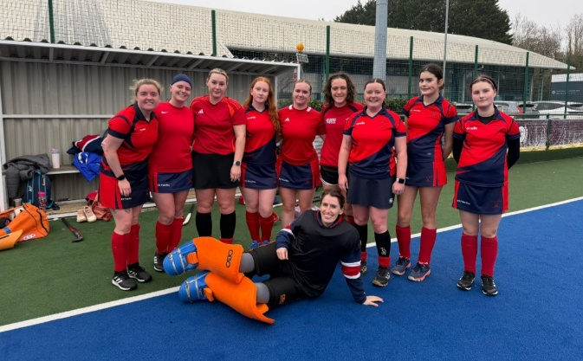
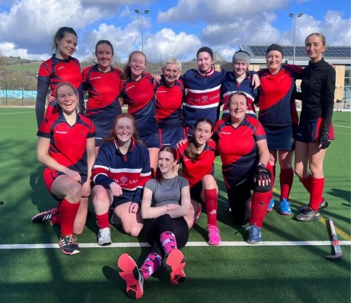
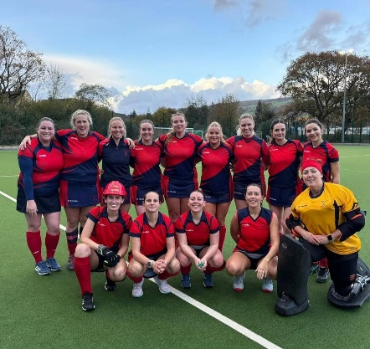
We are extremely grateful to Vicky Sutton and her team of coaches for all their hard work throughout this season. Our Senior Club members have thoroughly enjoyed her training sessions, and the progress players have made is reflected in our match results and final League positions. We are delighted that Vicky has accepted the position of Head Coach for the 2026/27 season and we look forward to working with her as the Club continues to move forward.

Our online marketing campaign and recruitment drive for both Senior and Junior membership continues to be an important aspect of the Club. We continue to work closely with Sport RCT to raise the profile of hockey. We have run two hockey camps this season at Abercynon Leisure Centre and Ysgol Afon Wen with over 30 children signing up for each session. This summer we will once again be on Sport RCT’s ‘Summer of Fun’ Programme with a planned Hockey Festival for Years 4,5 & 6 pupils in August.
There is still lots of work to do to recruit new members to the Club and we need all our members to keep encouraging players of all ages and abilities to come and join the Red Army!

Indoor Hockey continues to be popular with our members, and we entered two teams in the SW Hockey Indoor League this season. Twenty six members attended Indoor training sessions in the lead up to the Trophy & Challenge Competitions, held in Rhydycar and Cwmbran in December and January. Thanks to our Indoor Manager and coach for making this all possible.
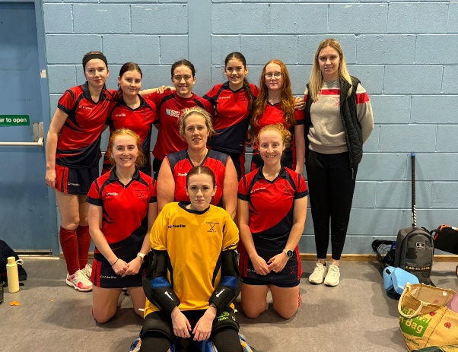
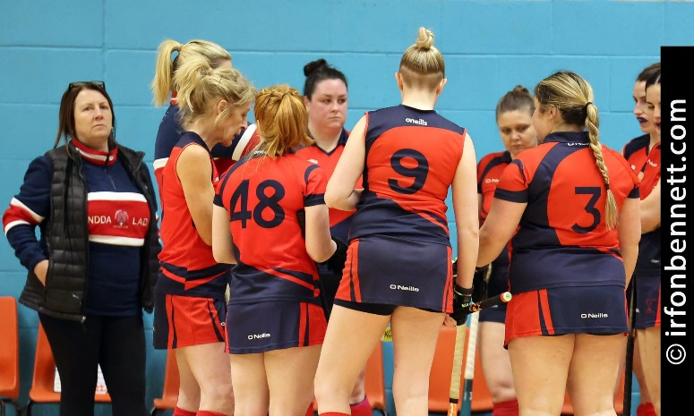
Congratulations to Kate Broaders who represented Wales 035s in the Indoor World Cup in Nottingham in March. The team put in a fantastic performance and narrowly missed out on
a medal. We wish Kay Tyler good luck for the Wales 065s Home Nations in Belfast and the Europeans in Brasschaat, Belgium later this summer.

One of the highlights of our Hockey Calendar is the Club Masters Weekend in Swansea. This annual event held in May was once again full of fun, madness, lots of laughter, sunshine and some 035s Hockey matches as well! Thanks to our army of supporters who love to attend this event!

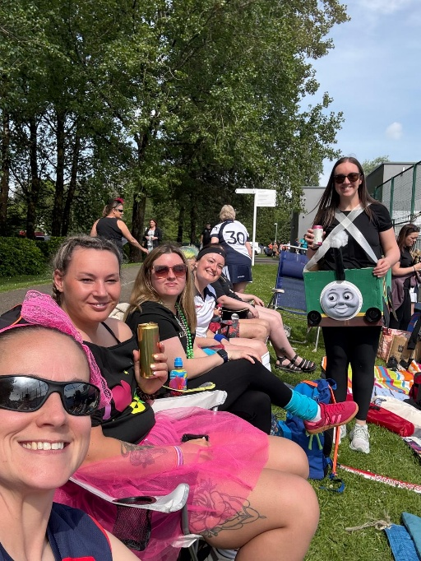
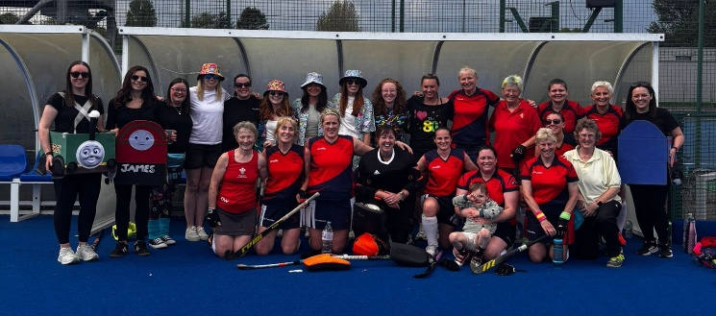

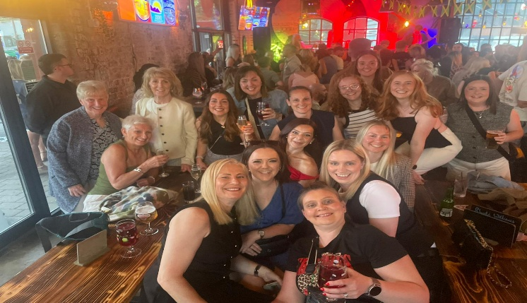

Club Junior Section

Our Junior members have once again shown excellent commitment to both Monday night training sessions and Sunday tournaments. They are a delightful group of young players who work hard in every session. They are keen to learn, practice and develop their hockey skills. As a result, their technique, game play and confidence have continued to improve over the course of the season.
We entered teams in the U8s & U12s SWYH Tournaments this season and attended ten Sunday morning tournaments in total. It was wonderful to see the improvement the players have made and we scored lots of goals in the process! The group are an absolute joy to coach and their enthusiasm for hockey and energy on the pitch is infectious!
Our juniors are the future of our Club and we are grateful for the wonderful support we receive from our parents and carers. The hard work and commitment of the volunteers who support our Junior Section is also acknowledged. Without their support Monday nights and Sunday Tournaments would not happen.
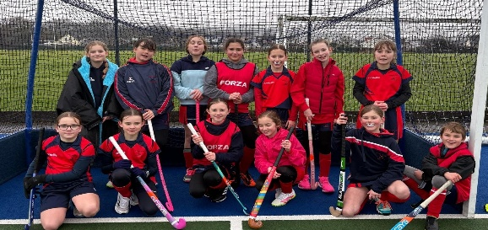
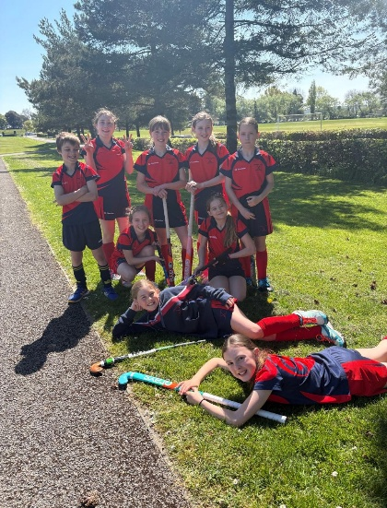
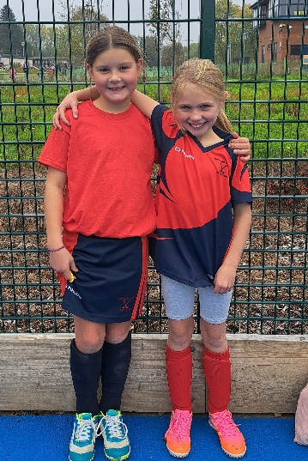

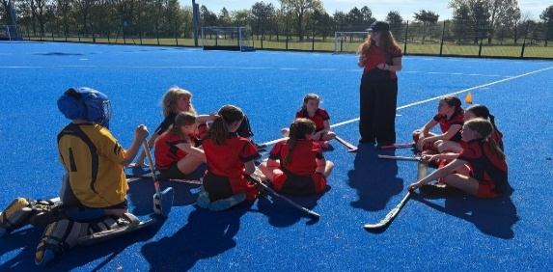

Off the pitch, Nicola Bevan once again organised our famous annual Christmas Shopping trip to Gloucester Quays, an important fundraising event for the Club and great fun! Our Junior members celebrated Christmas with a fabulous evening of Ten Pin Bowling @ Nantagrw while our Senior members enjoyed a brilliant night of celebrations in Cardiff

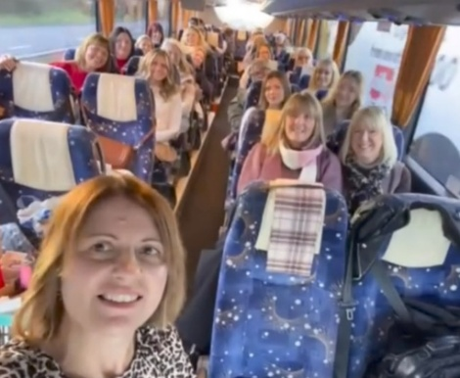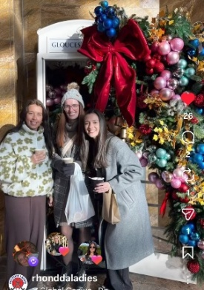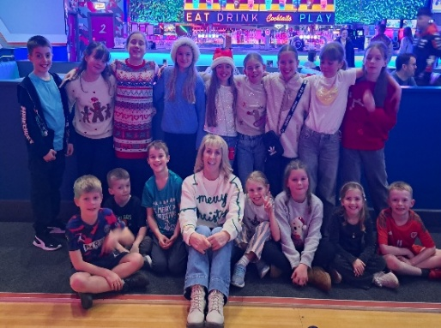
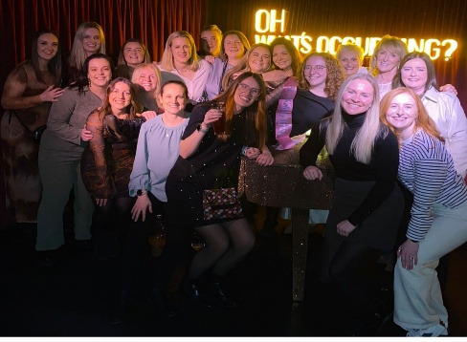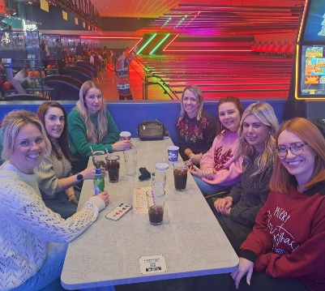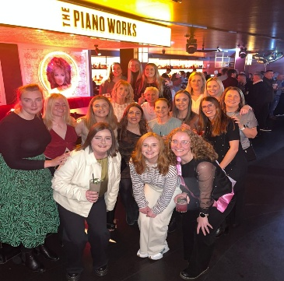

Finally, a big thank you to all our supporters, parents/carers/family members/friends who continue to support us both on and off the pitch. And a huge ‘thank you’ to all of our members – juniors and seniors; our volunteers, coaches, umpires & committee members who work so hard to ensure this club keeps going from strength to strength.

